Unity3D Android Export Settings 2019

Created: 20 October 2019 Updated: 20 October 2019

Table of Contents

Build Settings 0

Downloads/Settings 2

- Preferences 2

- SDK and NDK download 2

Project Settings 3

- Other Settings 4

- Publish Settings 5

## Build Settings

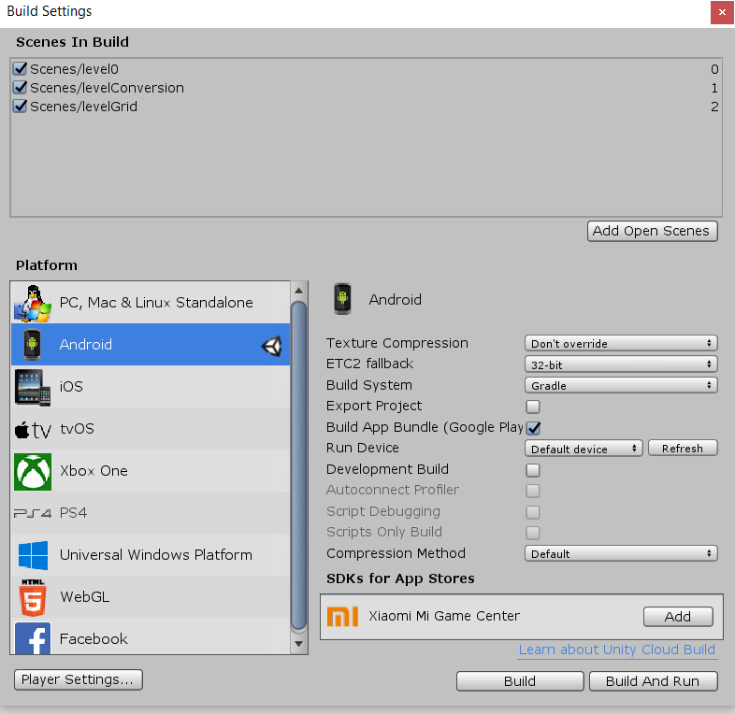

## Downloads/Settings

### Preferences

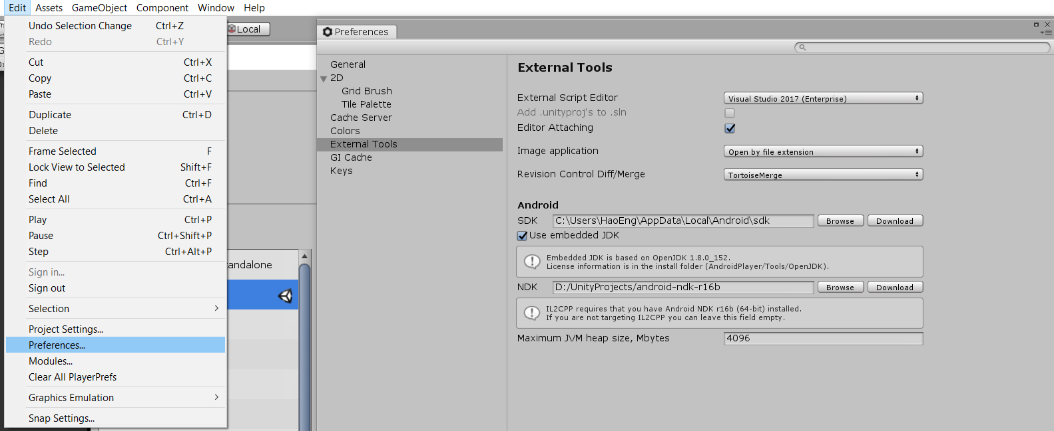

### SDK and NDK download

Download will takes some time, make sure to Browse and direct to the correct folder, Unity will help detect if the current folder contains the KIT

NOTE: NDK version is based on different version of unity, make sure to download the correct version or you will waste your time downloading the wrong one.

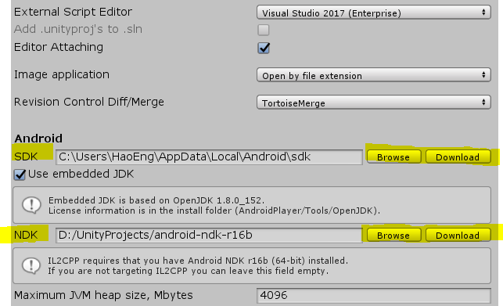

## Project Settings

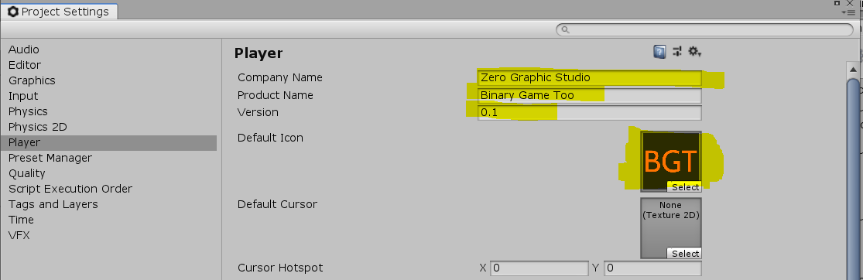

Company Name: 1 time only filled up

Product Name: 1 time only filled up

Version: Incremental

Default Icon: 1 time only

Default Cursor: 1 time only optional

### Other Settings

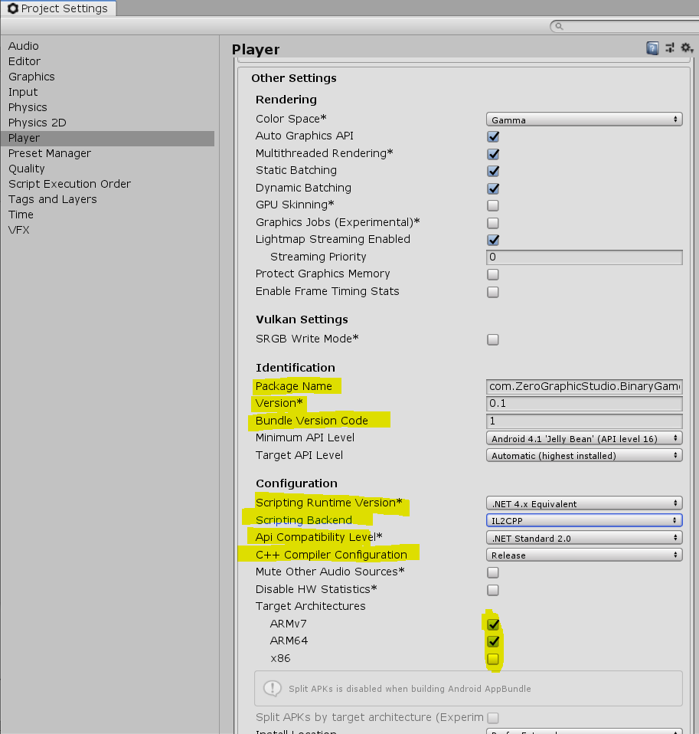

### Publish Settings

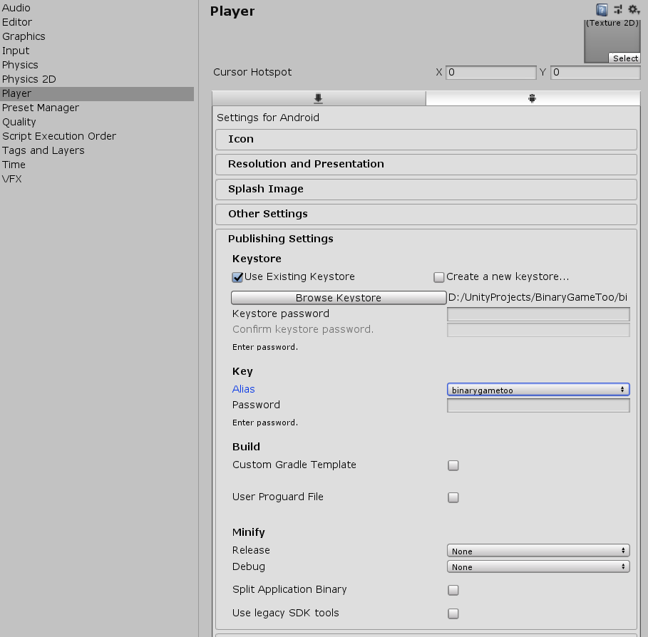

* No key Create a New key store, filled up the details and do not lose it.
* Each Key store is uniquely ties with a APK

## 